South Bumby Church of Christ | Online Bible Study Home

"The Bible Speaks" Correspondence Course
How To Understand
The Bible
WITH AUDIO!! | By Robert F. Harkrider ©1989

GENERAL INFORMATION ABOUT THE BIBLE
Lesson 1 
With this lesson you are beginning a study of the greatest book ever to be delivered into human hands. The Bible is the book of books. It has done more to change the course of human events than any other book ever printed. To engage in a successful Bible study one must understand a little about its make-up. All of the Bible is the word of God, but not all of it is in the form of commandments for us to obey today (e.g., "make thee an ark." Gen. 6:14). Therefore to properly understand, we must "rightly divide the word of truth" (2 Tim. 2:15). We can do this best if we first have an overall view of the Bible story.
I. | GENERAL MAKE-UP OF THE BIBLE
  A. | Its Name Indicates Its Pre-eminence.
    1. | The word Bible comes from the Greek word "Biblios" which means "a book."
    2. | Because of its importance God's Word is called "The Book of All Books."
  B. | The Bible Is Composed of Two Major Divisions.
    1. | Though the whole composition is called "The Book" the Bible is made up of 66 individual books which are divided into two major sections.
    2. | The Old Testament contains 39 books originally written in Hebrew by about 32 men over a period dating from about 1500 B.C. to 400 B.C. This part of the Bible tells of man's earliest existence and of God's first covenants with man.
    3. | The New Testament contains 27 books originally written in Greek by 8 men over a period dating from about 52 A.D. to 97 A.D. This is the record of God's covenant for man today. It is called "new" for the first covenant was set aside when this was given (Heb. 7:18; Heb. 8:13).
  C. | The Bible Is Inspired of God.
    1. | About 40 men wrote the Bible as God's Spirit directed them, 2 Peter 1:21.
    2. | They used the words given by the Holy Spirit, 1 Cor. 2:10-13; 1 Thes. 2:13.
    3. | Therefore the Bible is inspired (God-breathed), 2 Tim. 3:16-17; Eph. 3:3-5.
    4. | The unity of the Bible is one proof of its inspiration. These forty men lived over a span of 1600 years and had no possible way to confer with one another. They came from various backgrounds and social levels; they even wrote in different languages. Yet the Bible is without contradiction! Had the Bible been the work of 40 minds it would surely be filled with conflicting human opinions. Its unity proves that the Bible is from one mind-the mind of God!
II. | THE HISTORICAL PERIODS OF THE BIBLE
  A. | Three Dispensations of Time
    1. | Some Bible students believe the patriarchal form of God's revelation continued among the Gentile nations until the cross of Christ. They reason that the Israelite nation was called aside by God for a special purpose (the coming of Christ) and that the law of Moses was a special law given only to them. This view certainly does not conflict with the Bible statement of how God spoke in "times past" and "in these last days" (Heb. 1:1-2).
    2. | However, for the sake of clarity and because the Bible really does not give us a detailed picture of the Gentile nations after the development of Israel, we shall follow the basic chronological development of three distinct periods of Bible history.
  B. | The Basic Descriptions of These Three Periods
    1. | The Patriarchal (Father-rule) began at Creation and lasted until the giving of the law on Mt. Sinai. Its history is recorded in Gen. 1 to Exo. 20.
    2. | The Mosaic or Jewish (National) began at Mt. Sinai and lasted until the crucifixion of Christ. Its history is found from Exodus 20 to Acts 2. This law was to last for a definite time (Gal. 3:19-29). It was nailed to the cross (Col. 2:14-18). It was done away (2 Cor. 3). We no longer are bound by it.
    3. | The Christian (International) began at Jerusalem on the first Pentecost after the resurrection of Christ and will last until the end of time. Its record is found from Acts 2 through Revelation. We live under this. Heb. 1:1-2; 10:8-10.
THE PATRIARCHAL PERIOD
The first dispensation of Bible history is commonly called the "Patriarchal Period." An understanding of this age is important, for it tells of man's earliest relationship with God and answers many questions basic to understanding the rest of the Bible.
I. | SIGNIFICANT FACTS OF THE PATRIARCHAL PERIOD
  A. | Name
    1. | The word "patriarch" means "father, leader, chief, ruler"; therefore this period is literally called the age of "Father-Rule."
    2. | God revealed His will directly to the heads of the families who in turn taught their children (Heb. 1:1-2). There is no evidence of any written law during this age.
  B. | Man's Relationship to God
    1. | As God spoke to the fathers by dreams, angels, or visions, they would instruct their children, thus this is sometimes called an age of family religion (Gen. 18:19).
    2. | Worship consisted of animal sacrifices offered upon altars (Gen. 8:20; 12:7-8).
  C. | Duration
    1. | We will relieve the Bible of many pressures if we will keep in mind that it was written for religious ends rather than scientific or chronological purposes. We are not given an exact date for creation nor can we be certain that every generation from Adam is specifically mentioned. On the basis of what is revealed this period lasted at least 2500 years, perhaps longer.
    2. | This period begins with Creation, recorded in Gen. 1, and continues until the giving of the Ten Commandments recorded in Exodus 20.
  D. | Importance of the Patriarchal Period  The Bible record of the Patriarchal Period does not go into detail about every event or person, but what is told answers some important questions which give us a deeper understanding of the rest of the Bible. Let us consider some:
II. | QUESTIONS ANSWERED BY THE SIGNIFICANT EVENTS OF THE PATRIARCHAL PERIOD:
  A. | How Did All Things Begin? (The Creation)
    1. | All things started with a miracle of God, Genesis 1:1-2:3.
    2. | The atheist must start somewhere-all things came from nothing? FANTASTIC! WHO CAN BELIEVE IT?
  B. | What Makes Man Superior To Animals? (The Creation of Man In God's Image)
    1. | Man created in God's image-spirit, intelligence, dominion, Gen. 1:26-28; 2:7-8.
    2. | Institution of marriage-woman, an help suitable for man, Gen. 2:18-24.
  C. | Why Do We Need God, Salvation, or the Bible? (The Fall of Man)
    1. | Man's first relationship with God was ideal. God placed man in the Garden of Eden and provided every necessary thing, Gen. 2:8-17.
    2. | Man is in God's image, thus God did not force Adam to serve Him. The devil tempted; man fell by his own choice; his return will be by choice, Gen. 3:1-13; Rom. 6:16-18.
  D. | Will God Really Destroy That Which He Has Created? (The Flood)
    1. | Man's wickedness increased; God purposed to destroy the world, Gen. 6:5-7.
    2. | Through the righteousness of Noah eight souls were spared, Gen. 6:8-10:32.
    3. | God has promised to destroy the world again, 2 Pet. 3:1-14.
  E. | How Did Man Become Separated Into Different Nations? (The Division of Man)
    1. | The Tower of Babel-confusing of tongues, Gen. 11:1-9.
    2. | The descendants of Shem, Ham, and Japheth, Gen. 10, 11.
  F. | Who Are The Jews, and Why Were They God's Chosen People? (The Call of Abraham)
    1. | The Land promise (Canaan, Palestine), Gen. 12:1.
    2. | The Nation promise (Israel, Hebrews, Jews), Gen. 12:2.
    3. | The Spiritual promise (Christ), Gen. 12:3, "bless all families ..." Gal. 3:26-29.

Explain This Chart
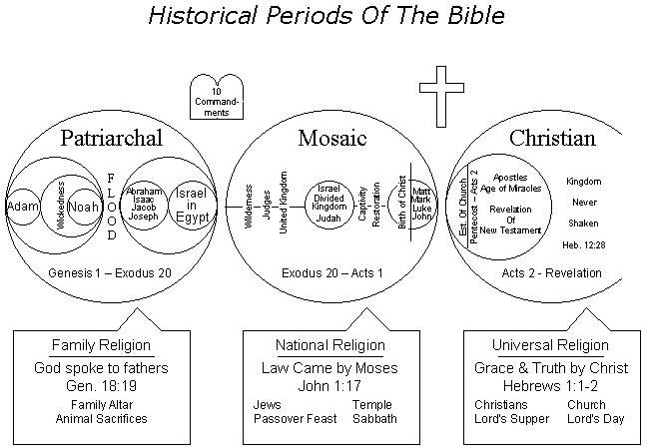
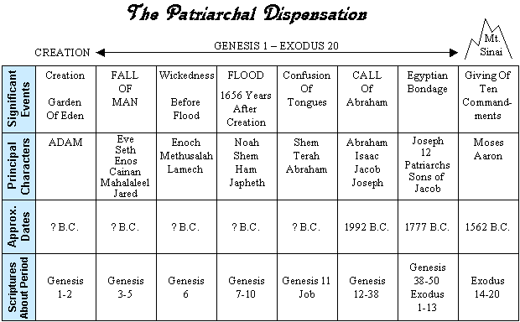
HOW TO UNDERSTAND THE BIBLE
STUDY QUESTIONS for Lesson 1
Take an Interactive Online Quiz!
I. ANSWER THE QUESTIONS:
1. What does the word "Bible" literally mean? ____________________________

2. Name the three basic periods of the Bible and give their duration.

a._____________________________________________________________________

b. ____________________________________________________________________

c. ____________________________________________________________________

3. Why is the first age called the "Patriarchal Period"? _________________

_______________________________________________________________________

4. In what language was the O.T. originally written? _____________________

5. Where is the historical record of the Patriarchal Period found? _______

_______________________________________________________________________

6. What makes man superior to animals? (Gen. 1:26-28) ____________________

_______________________________________________________________________

7. Why do we need God, salvation, or the Bible? (Gen. 3:1-13) ____________

_______________________________________________________________________

8. What assurance do we have that God will destroy the world? (Gen.

6:5-7; 2 Peter 3:7) ___________________________________________________

_______________________________________________________________________

9. How did man become separated into nations? (Gen. 11:1-9) ______________

_______________________________________________________________________

10. Who are the Jews, and why are they called God's "chosen people"?

(Gen. 12:1-3) _________________________________________________________

_______________________________________________________________________

II. TRUE OR FALSE:

____ 1. To our knowledge God did not provide any written law during
the Patriarchal Period.

____ 2. Moses lived before Abraham was born.

____ 3. Jacob lived before the flood.

____ 4. Methuselah lived longer than any man, but he died before his
father (Gen. 5:21-27).

____ 5. There are 66 books in the Bible written by about 40 different
men who lived over a span of 1600 years.
Name: ______________________________________________________ Grade ______
Address: ________________________________________________________________
City: ______________________________________ State: __________ Zip: __________
[ ] | I am interested in viewing the VHS tapes which will assist me in studying this Correspondence Course.
[ ] | I would like for someone to study with me in my home
Fill out questions and mail to:
South Bumby Church of Christ
P.O. Box 560207
Orlando, Florida 32856
Send mail to webmaster@bumby.org with questions or comments about this web site.

